**Exercise**

Make the following assembly Use:

- 4 x assembly shown in Figure B.

- 2 x assembly shown in Figure C.

A different color is used for each assembly occurrence in Figure A in the image shown below.

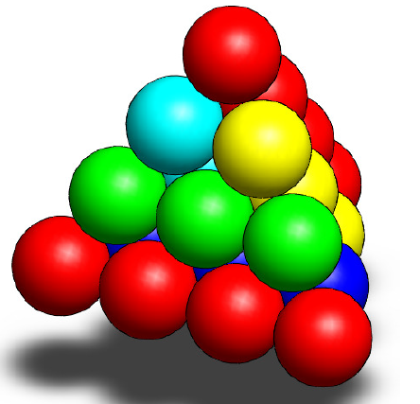

***Final Assembly***

***Instructions :***

1. Make a sphere with a diameter equal to 60 mm.

***Figure A***

1. Make an assembly using the sphere from exercise 5-6a three times. The spheres should all sit in a row and touch each other.

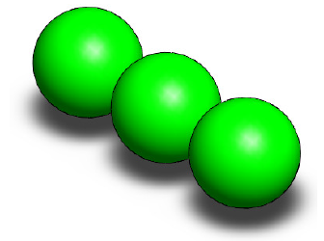

***Figure B***

1. Make an assembly using the sphere from exercise 5-6a four times. The spheres should all sit in a row and touch each other.

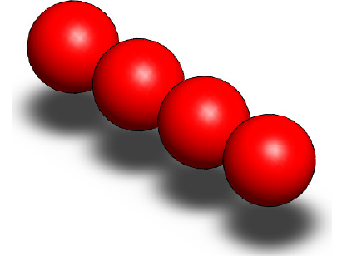

***Figure C***